**Lab Manual for Embedded System Design**

**Lab No. 11**

**Serial USART Interface Programming using**

**Arduino UNO Board**

*Objectives*

*Understanding the basic concept of serial usart interface programming and implementation of concepts on Arduino UNO and IDE*

# LAB # 11

**Serial USART Interface Programming using Arduino UNO**

**Board**

## Introduction

Used for communication between the Arduino board and a computer or other devices. All Arduino boards have at least one serial port (also known as a UART or USART), and some have several.

|  |  |  |  |  |  |
| --- | --- | --- | --- | --- | --- |
| **BOARD** | **USB CDC**  **NAME** | **SERIAL PINS** | **SERIAL1**  **PINS** | **SERIAL2**  **PINS** | **SERIAL3**  **PINS** |
| Uno, Nano,  Mini |  | 0(RX), 1(TX) |  |  |  |
| Mega |  | 0(RX), 1(TX) | 19(RX),  18(TX) | 16(RX),  17(TX) | 15(RX),  14(TX) |
| Leonardo,  Micro, Yún | Serial | 0(RX), 1(TX) |  |  |  |
| Uno WiFi  Rev.2 |  | Connected to USB | 0(RX),  1(TX) | Connected to  NINA |  |
| MKR boards | Serial |  | 13(RX),  14(TX) |  |  |
| Zero | SerialUSB  (Native USB  Port only) | Connected to Programming  Port | 0(RX),  1(TX) |  |  |
| Due | SerialUSB  (Native USB  Port only) | 0(RX), 1(TX) | 19(RX),  18(TX) | 16(RX),  17(TX) | 15(RX),  14(TX) |
| 101 | Serial |  | 0(RX),  1(TX) |  |  |

On Uno, Nano, Mini, and Mega, pins 0 and 1 are used for communication with the computer. Connecting anything to these pins can interfere with that communication, including causing failed uploads to the board.

You can use the Arduino environment’s built-in serial monitor to communicate with an Arduino board. Click the serial monitor button in the toolbar and select the same baud rate used in the call to begin().

Serial communication on pins TX/RX uses TTL logic levels (5V or 3.3V depending on the board). Don’t connect these pins directly to an RS232 serial port; they operate at +/- 12V and can damage your Arduino board.

To use these extra serial ports to communicate with your personal computer, you will need an additional USB-to-serial adaptor, as they are not connected to the Mega’s USB-to-serial adaptor. To use them to communicate with an external TTL serial device, connect the TX pin to your device’s RX pin, the RX to your device’s TX pin, and the ground of your Mega to your device’s ground.

## Time Boxing

|  |  |  |
| --- | --- | --- |
| **Activity Name** | **Activity Time** | **Total Time** |
| Login Systems + Arduino & Proteus | 3 mints + 5 mints | 8 mints |
| Walk through Theory & Tasks | 60 mints | 60 mints |
| Implement Tasks | 80 mints | 80 mints |
| Evaluation Time | 30 mints | 30 mints |
|  | Total Duration | 178 mints |

## Objectives

This Lab exercise delivers the idea/concept of:

* Understand the purpose/ advantage of using Arduino UNO.
* Understanding Usart Interface peripheral programming.

## Lab Tasks/Practical Work

**1. In this task, we will write a program to print a string on serial monitor.**

**Solution:**

void setup() {

// put your setup code here, to run once:

Serial.begin(9600); // begin serial communication , define baud rate.

}

void loop() {

char string[10] = "Embedded";

int index=0;

for(index=0 ; index <9 ; index++)

{

Serial.print(string[index]);

}

// put your main code here, to run repeatedly:

Serial.println(" ");

delay(500);

}

**Output:**

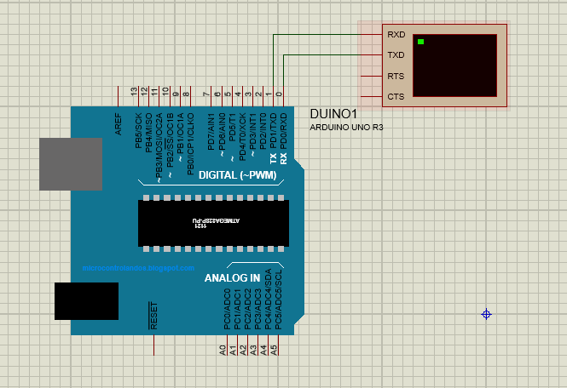

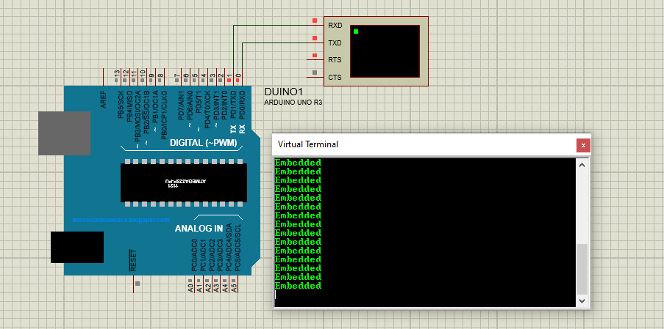

**2. In this task we will control the LED on “Arduino 2” using SPDT switch on “Arduino 1” through UART communication.**

**Solution:**

**Arduino 1:**

int SPDT =7;

void setup() {

pinMode(SPDT,INPUT);

Serial.begin(9600);

// put your setup code here, to run once:

}

void loop() {

// put your main code here, to run repeatedly:

int button_status = digitalRead(7);

Serial.write(button_status);

//delay(500);

}

**Arduino 2:**

int LED = 4;

void setup() {

// put your setup code here, to run once:

pinMode(LED,OUTPUT);

Serial.begin(9600);

}

int x =0;

void loop() {

if(Serial.available() > 0)

{

// put your main code here, to run repeatedly:

x = Serial.read();

if (x == 1)

{digitalWrite(LED, HIGH);

}

else

{ digitalWrite(LED,LOW);

}

}

}

**Output:**

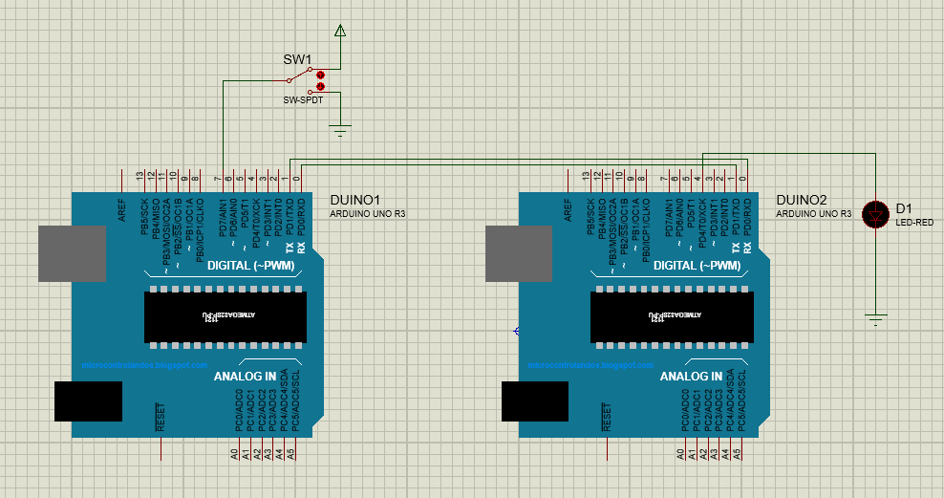

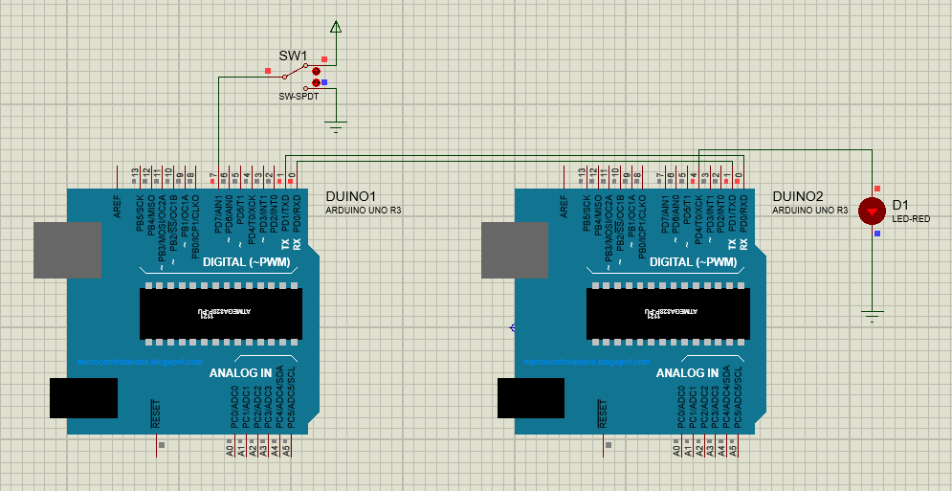

**3. Develop a Program which provide serial usart interfacing programming using Arduino UNO board.**

**Solution:**

**Master:**

#include <SoftwareSerial.h>

SoftwareSerial softSerial(10, 11);

void setup()

{

softSerial.begin(9600);

}

void loop()

{

softSerial.write("UART Communication");

delay (100);

}

**Slave:**

#include <SoftwareSerial.h>

SoftwareSerial softSerial(10, 11);

char ip;

void setup()

{

softSerial.begin(9600);

}

void loop()

{

if (softSerial.available())

{

ip=softSerial.read();

softSerial.print(ip);

}

}

**Output:**

